The following details the process of building the apparatus required to assemble a fully automated version of the Farr-Whishaw box mouse pellet retrieval paradigm for a variety of applications. Included elements: limb specifying Farr-Wishaw boxes, conveyor belt apparatus, box racks, as well as diagrams of several 3D-Printable objects which will also be included in supplements elsewhere (Note: create GitHub for the lab with a subsection for this project including the files listed herein).
- Creating the conveyor belt:
  - Materials
    - See materials excel file
  - Procedure
    - 3D Print the included files in ABS. Higher quality settings are better.
    - Baseboard Preparation
      - Measure and mark the baseboard with a permanent marker according to the following schematic, then mark the opposite side of the PTFE baseboard (listed units are in mm):
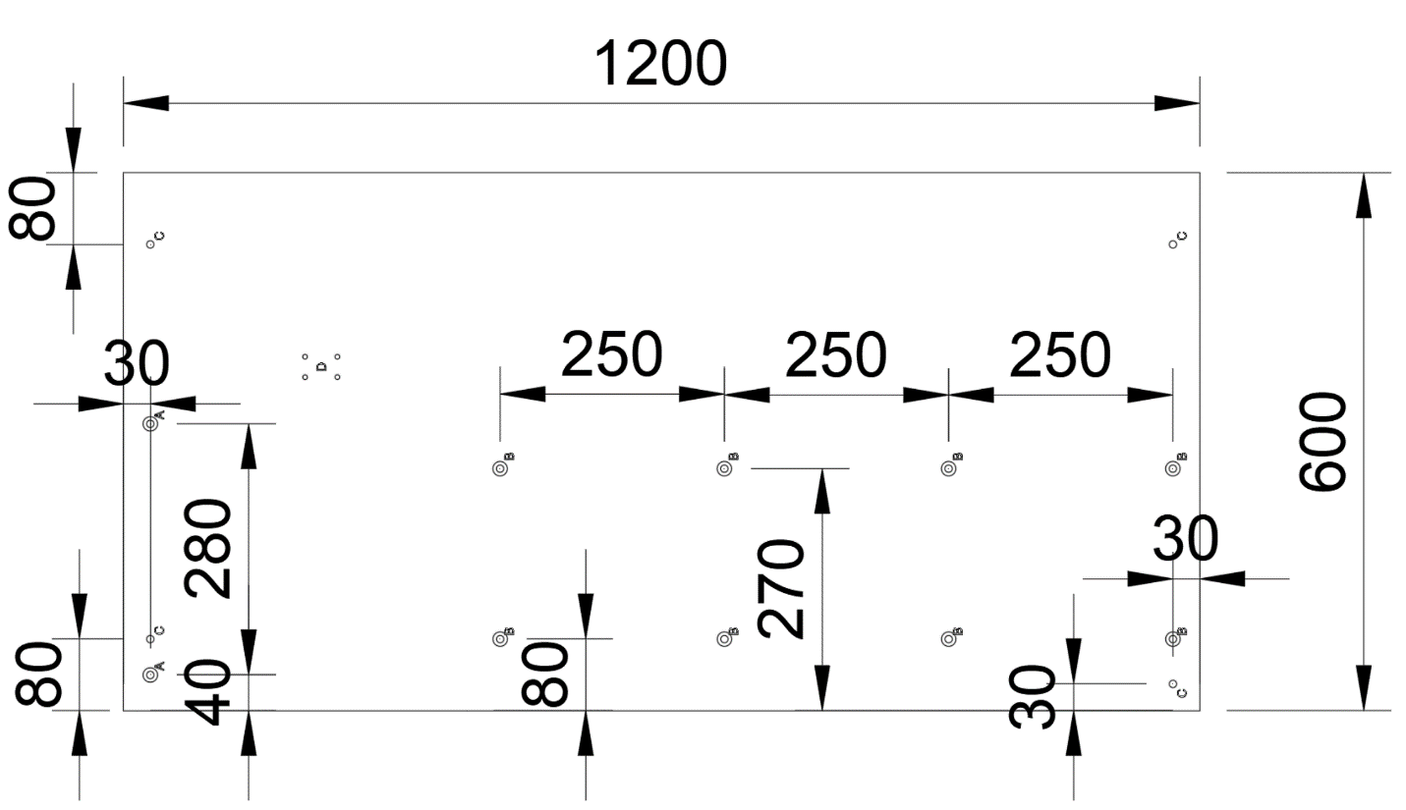
      - For the next steps a drill press will give better results, though a steady hand and a regular powered handheld drill will work. PTFE is best drilled through with bits that scrape material away so you may have to try different kinds.
      - On the marked points labeled “C”, recess the back side with a 7/8” bit. Do this just deep enough to accommodate the depth of the bolt head (measure the bolt head height and then use the drill press depth gauge to recess that depth). If a different bolt is used, a wider or narrower bit may be needed. Test fit a ratchet bit fitting the bolt head to ensure it will fit in the recessed width and widen the recessed area if needed to accommodate.
      - Drill a hole the rest of the way through areas marked “B” and “C” from the top side with a 3/8” bit. Slightly recess “B” from the rear.
      - For the points labeled “A,” repeat step 1.b.3. substituting a 5/8” bit.
      - Drill through “A” from the top with a ¼” bit.
      - Flip the board so the bottom side is up and place “A” and “B” bolts into “A” and “B” holes. Flip the board back over carefully.
    - Create the pully assembly
      - Use a FDM 3D printer to print the pipe-cap model in the strongest material easily accessible to you.
      - Attempt to put the pipe-cap on the pipe. If too big, evenly wrap the end of the pipe with electrical tape to adjust pipe diameter.
      - Push the pipe into the cap as far as possible (variation in depth possible will be accounted for when cutting the conveyor belt width). This should be a secure fit.
      - Insert and screw M4 set/grub screws in the M4 holes of the cap print to secure it fully in place.
      - With the protruding portion facing the opposite end of the pipe, slide one of the pillow blocks onto the pipe and snug to the pipe cap. Tighten the set/grub screws included with the pillow block.
      - Add the other pillow block to the opposite side of the pipe but rotate it so the protruding portions are facing each other. This block should only be placed far enough onto the pipe that the set screw holes are covered. This can be checked by looking down the bore of the block from the open side. Tighten the included set screws.
      - Place the entire assembly on a surface such that the blocks sit flat on the table and the cap is on the far side. The left side holes in the feet of the blocks will receive bolts to host turnbuckles which will be used to tension the conveyor and timing belts later.
    - Attach the roller blocks
      - Using a small screwdriver, press in the retractable ends of the axels of the roller blocks and remove the rollers from the blocks.
      - Keeping everything in its current orientation to enable consistent tracking, remove anything on top of the baseboard and lift the edge of the baseboard to access the bolt holes.
      - Place the correct type of bolt through holes B such that the head of the bolt is on the bottom of the baseboard and the bolts protrude from the top of the baseboard.
      - Add the blocks to the top of the baseboard by placing them on the bolts and adding first a matching washer, then a lock nut to each bolt: do not tighten completely.
      - Repeat step 4 until all blocks are in place.
      - Tighten nuts completely.
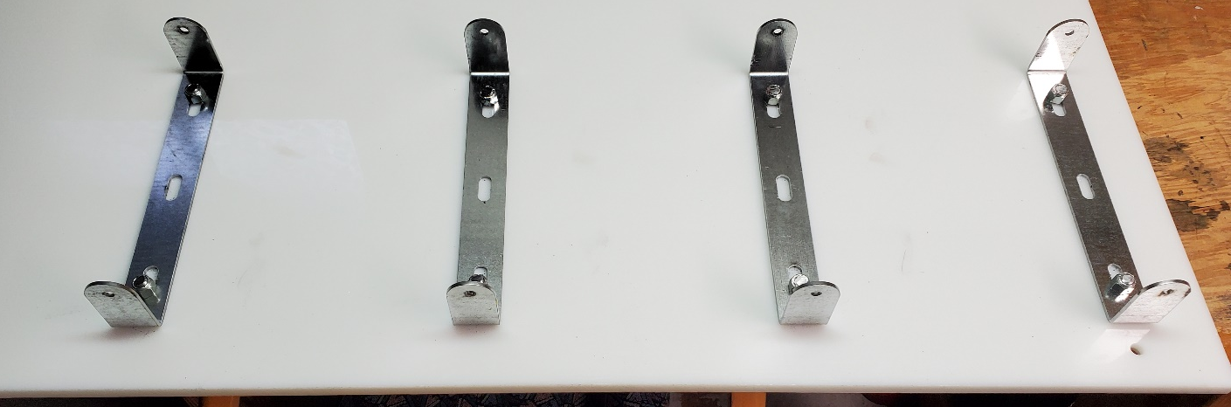
    - Attach the pulley to the baseboard with turnbuckles
      - Insert the turnbuckle bolts through a washer and into the baseboard from the bottom, add a washer on the top side of the baseboard and secure it in place with a lock bolt.
      - Add another lock nut to increase the resting height of the turnbuckle eye.
      - Disassemble the 2 turnbuckles into 6 parts: 2 left eye bolts, 2 right eye bolts, and 2 buckles.
      - Thread the turnbuckle bolt through the eye of each left eye bolt for both bolts.
      - Secure the eye bolts in place with another lock nut on each bolt.
      - Put a smaller washer then a larger washer on two bolts. With the timing gear away from you, insert the bolts into the underside of the left side holes of the pillow blocks, put the eye of the right eye bolt over the bolt from the top side of the pillow block, and add a lock nut to secure it in place. The bolt may be trimmed with bolt cutters if desired.
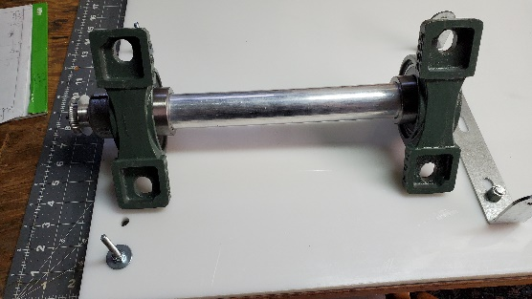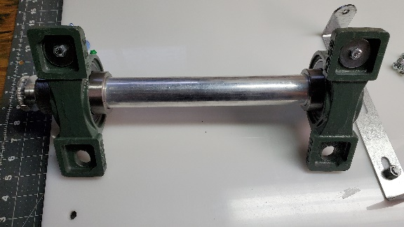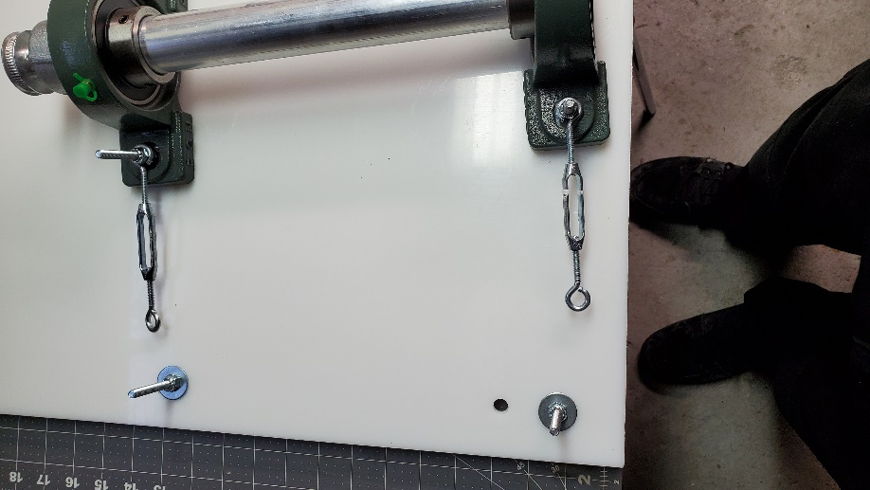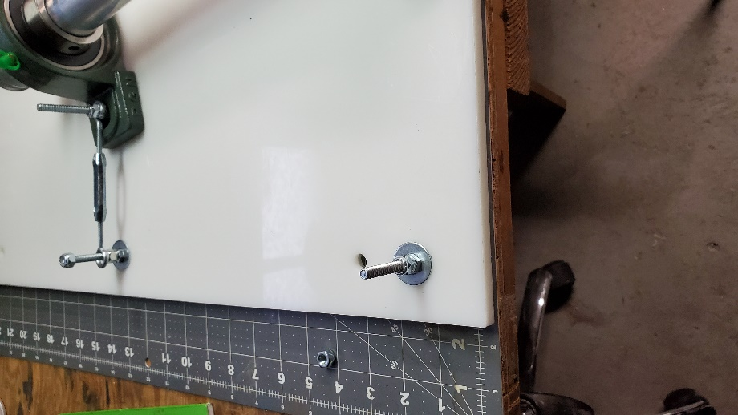

      - Screw the right twist side of each buckle ~3/4in onto the right twist eye bolt.
      - Place the pulley assembly on the baseboard with the timing belt gear away from you. Place the ends of the left eye bolts into the open left twist ends of the buckles and tighten equally, but not completely.
    - Cut the conveyor belt material
      - Measure the length of the pulley rod and the width of the belt material. If the belt is wider than the pulley rod, the belt will need to have a strip of material removed to fit, in the case of the belt from our materials section, we ended up needing to remove some amount of material from the width.
      - Make sure the leading end of the belt is perfectly straight and that the corners are at proper right angles.
      - Loosen the turnbuckles as much as possible without disconnection.
      - Place the roll of belt material on the rightmost end of the baseboard with the underside of the belt material facing up. Pull the belt from right to left through the uprights of the blocks and under the pulley rod.
      - Install the rollers of the roller blocks.
      - Wrap the belt over the top of the pulley rod and bring it back to the roller on the right end of the baseboard.
      - With a marker in hand, wrap the free end of the belt around the rightmost roller so it would meet the trailing side of the belt were it lifted to the bottom of the roller. While holding the leading end in place, apply slight tension to the trailing side by pulling away from the right side of the baseboard and slightly up. If struggling with this step, thoroughly tape the leading end to the roller and slightly tension the trailing edge around the roller. Mark the trailing section where it meets the corners of the leading end.
      - Use a straight edge to mark a proper right angle and draw a straight line across the entire width of the belt on the underside. Carefully cut straight along this line.
      - Size two alligator clips to the same width as the belt (make sure to do this with the pieces stitched together to prevent overlap).
      - Remove the belt, the rollers, and disconnect the closer of the two turnbuckles.
      - Using the installation bar, thread two alligator clips together. Slightly retract the installation bar so as not to cut it, cut the clips to the length of the belt’s width.
      - Lay the belt face down and place a thick disposable cutting board over it. Wrapping the belt ends over the edges of the board so the top of the belt is now showing, bring them together so they meet over the board. Place the end edges of the belt as much as possible into each side of the mouths of the clips. Press the edges together and down while using a hammer to close the clips onto the belt ends. Remove the installation bar and replace it with a stay bar. Clip the stay bar to match the width of the belt.
      - Remove the cutting board and move the belt to the baseboard. Face the straighter edge of the belt away from you and thread the pulley rod through the belt such that a pillow block is on either side of the belt. Set the belt into the roller mounts and install the rollers. You may need to completely detach the pulley from the other turnbuckle to accomplish this.
      - Reattach the turnbuckle(s) and tighten them to tension the belt slightly.
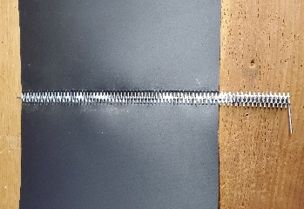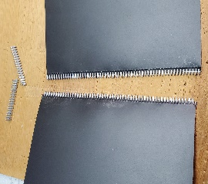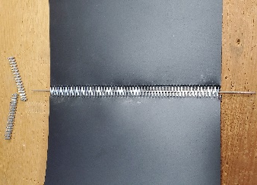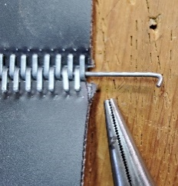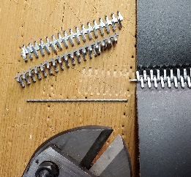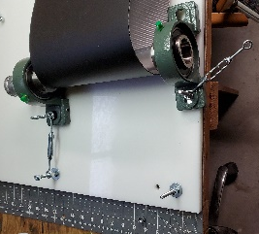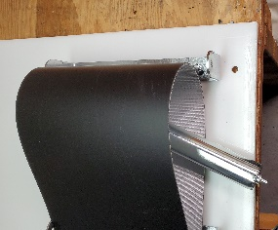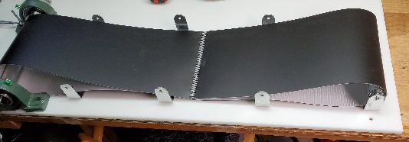
    - Attach the motor
      - Orient the motor mount so the baseplate (the tip of the L profile) is towards you and the baseboard attachment slots are touching your work surface.
      - Orient the motor so the drive shaft is towards you. Use the supplied screws to attach the motor to the back side of the motor mount such that the drive shaft faces you.
      - Place the timing belt gear onto the drive shaft and ensure clearance between it and the upright of the motor mount.
      - Maintaining all previous orientations, place the motor/mount assembly to the right of the pulley assembly’s timing gear, on the far side of the belt. Attach the timing belt to both timing gears. Apply slight tension by pulling the motor/mount away from the pulley, ensuring the timing belt remains parallel to the conveyor belt. Mark the front and right side of the motor mount base.
      - It is important to completely rotate the pulley rod to check alignment of the motor mount while tension is applied relative to the initial mark that was just made. Try to find the right most and left most that the motor assembly moves (though it should not move if everything has been done correctly) and then mark the exact middle of this position if movement does occur when the pulley rod is rotated.
      - Remove the motor/mount and timing belt. Check to ensure that the front baseplate mark is parallel to the conveyor belt and the right mark is perpendicular to the conveyor belt and the front mark.
      - Detach the drive shaft timing belt gear and motor from the mount and place the mount back on the baseboard, aligning it with the previous marks. Mark the mounting slits at the far ends of each slit for a total of 4 marks.
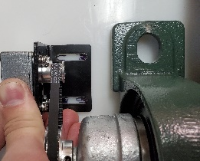
      - Use a “D” size drill bit to drill 4 holes in the baseboard where the 4 marks were made. Recess these holes (on the backside of the baseplate) to accommodate the 4 “D” bolts and then push said bolts through the bottom of the baseplate. Place the baseplate on the bolts so it remains in the prior orientation. Place “D” washers and “D” lock bolts onto the bolts and tighten everything down. Trim the bolts with a bolt cutter if necessary. Reinstall the motor and timing belt gear.
      - Loosen the turnbuckles and reinstall the timing belt. Tighten the turnbuckles to apply full tension to the timing belt and conveyor belt simultaneously.
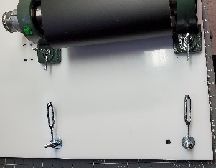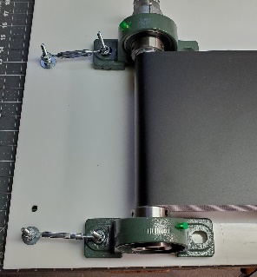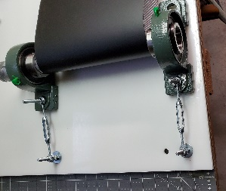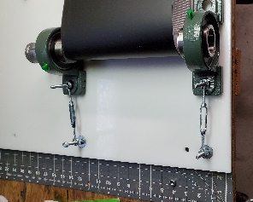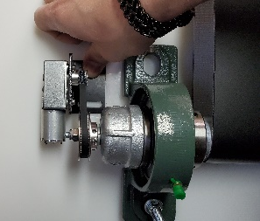
    - Build the Arduino shield:
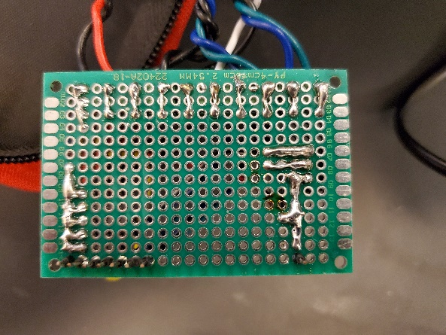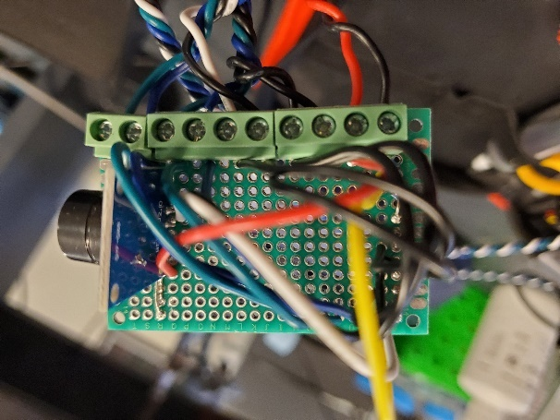
      - Gather materials and establish a productive mise en place
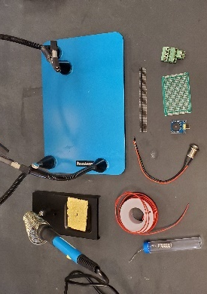
      - Break a multipin connector down to fit the length of board.
      - Use a multi-arm soldering helper to hold the shorter ends of the pins into the board and use some solder to tack them to what will become the top of the board. It’s easier if you tack pins that you won’t be using.
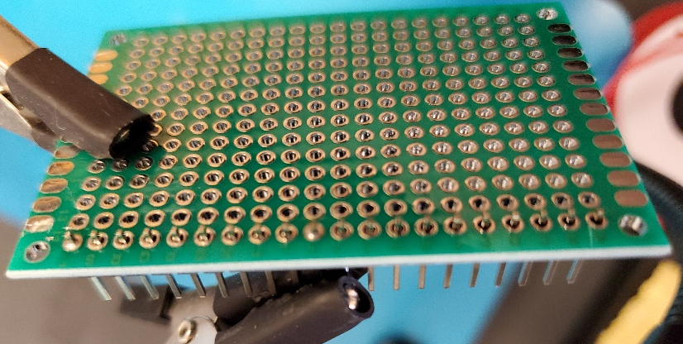
      - Place solder on terminals as noted in the image below, with the block on top and the pins below. A1 should be empty, B1 full, and so on. Bend pins to hold terminals in place.
      - Insert piezo buzzer from the top of the board such that the speaker faces the outside of the board, with pins into S6, S7, and S8. Bend the pins away from the edge to keep it in place and prepare for connections. This can be tacked in place with solder from the bottom if desired.
      - Strip the end of and insert a wire into P7 from the top to the board, bend the wire from the bottom of the board, use the hold assistant to hold the bent portion of the wire against the bent portion of the center pin, solder the two together and to the board.
      - Insert another stripped wire into R11, bend it from the bottom side of the board, turn it towards the pin of the buzzer inserted into S9, tack if desired. Completely strip some wire and insert it into R12. Bend this wire on both top and bottom in opposite directions to create a “Z” shape. On the bottom end, touch the bent wire to the other wire in R11, on the top, touch the out pin in R13 (this pin will serve to connect the board to the 5V connection on the Arduino unit), tack if desired. Using the helper to hold everything in place, solder all 4 referenced points together and to the board on whichever side the connections occur. Remove overhanging wire on the top from the connection of the “Z” to the pin.
      - Strip and insert a wire into P8 from the top, bending it on the bottom. Use the holder to assist as you hold it to the bent pin of the buzzer inserted into S6 and solder to each other and the board.
      - Strip and insert a wire from the top of the board into B4 and bend it on the bottom side to keep it in place. Bend the wires of a 100kΩ resistor into a “U” shape such that one of the two wires can be placed into B3 and the other into A8 from the top and push the resistor down to the top of the board (leaving a little space between it and the board. From the bottom side, bend the wire sticking out of B3 such that it comes into contact with the pin of the terminal block sticking out of B1. Also on the bottom side, align the bent wire which was placed into B4 such that is it touching the resistor wire through B3. Use the holder to keep these together while you solder them together and to the board and clean up any overhang by clipping the excess away. From the bottom, bend the other wire of the resistor which such that it spans between A8 and A13. Insert this wire back through A13 to the top of the board. On the top of the board, bend this wire such that it touches the top of the pin which is inserted into A14. Solder this together and to the board from the top. This will serve as the ground wire and all other grounds will be connected to this wire.
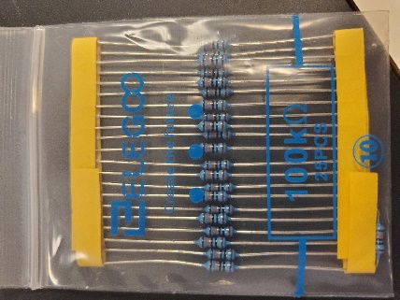
      - Strip and insert 4 wires from the top of the board, 1 into each position: B8, B9, B10, and B11. Bend each from the bottom towards the ground line. Solder each wire to the board and to the ground line. Also solder the ground line to the board.
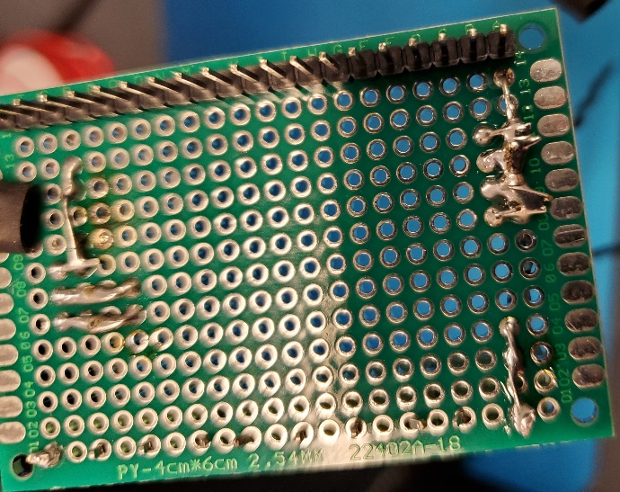
      - Strip a large section of and insert 4 wires from the top of the board, 1 into each of these position: D12, E12, F12, and G12. Feed each wire from the back to the top of the board by placing the wire coming out of D12 into D13, E12 into E13, F12 into F13, and G12 into G13. From the top, gently pull the wires tight to create small “U”-shaped sections of wire (making sure these are tight enough to the bottom of the board that they won’t interfere with the ability to plug the pins into the Arduino unit). Bend each wire over such that the wires poking through to the top connect to the pin on top as such: D13 to D14, E13 to E14, F13 to F14, and G13 to G14. Use holders to keep everything stable and solder wires to pins, pins and wires to the board from the top and also the “U”-shaped wire sections to the board from the bottom. Clip clean any wires protruding over the edge of the board. (A note on the figures. One of the black wires from the last step broke and I needed to strip it, move it, remove the old solder, and re-do it. This doesn’t effect function and happens in a couple of other places if I recall correctly. These can be largely ignored for the purposes of building yours, unless you need to know a way to fix a mistake, in which case, this is one way to do that.)
      - Strip the other end of the cable protruding from P9 and insert it into C10 from the top. Bend the wire from the bottom toward the previously laid ground lines and solder it to that.
      - Strip a large amount of the opposite end of the wire protruding from P8 and insert it into B12. Strip a large amount of the opposite end of the wire protruding from B4 and insert it into C12. Repeat the process of creating “U”-shaped elements on the bottom of each wire. From the bottom, pass the wire from B12 through B13 and C12 through C13 and pull each from the top to snug the “U” to the bottom of the board. On the top of the board, bend the wire protruding from B13 to contact the pin on B14 and C13 to contact the pin on C14. Use the holder to assist as you solder from the top of the board the wire from B13 to the pin from B14 and the wire from C13 to the pin from C14.
      - If you still haven’t tacked all the “U”-shaped wires to the bottom of the board, do that now.
      - The next process is going to be repeated in a pattern in the next which should be determinable from the figure, but detailed steps will also be included. The ground and instruction pin connected wires are going to be connected to the terminal block pins such that they do not cross each other as they are applied. The terminal pins are spaced with a gap in position so then applying wires to these positions, “space skipping” will occur. For reference in understanding what is about to occur, orient the board such that it matches the figure (right). The leftmost wire extruding from the board (black in the figure) will be placed in the leftmost open terminal pin, the next wire to the right into the next to the hole which accords with the next rightmost open pin (this will involve “skipping” a space), and so on. The next 8 steps will detail exact positions to further clarify, but if this pattern is followed, everything will come out correctly.
      - Strip the other end of the wire from B8 and insert it into the top of F3, from the bottom, bend it to contact F1 terminal block pin.
      - Strip the other end of the wire from B9 and insert it into the top of H3, from the bottom, bend it to contact H1 terminal block pin.
      - Strip the other end of the wire from B10 and insert it into the top of J3, from the bottom, bend it to contact J1 terminal block pin.
      - Strip the other end of the wire from B11 and insert it into the top of L3, from the bottom, bend it to contact L1 terminal block pin.
      - Strip the other end of the wire from D13 and insert it into the top of N3, from the bottom, bend it to contact N1 terminal block pin.
      - Strip the other end of the wire from E13 and insert it into the top of P3, from the bottom, bend it to contact P1 terminal block pin.
      - Strip the other end of the wire from F12 and insert it into the top of R3, from the bottom, bend it to contact R1 terminal block pin.
      - Strip the other end of the wire from G13 and insert it into the top of T3, from the bottom, bend it to contact T1 terminal block pin.
      - From the bottom, ensure all pins are contacting correctly, remove overhangs, and use the holder to help as you solder each wire to the board, each pin to the board, and each wire to the correct corresponding pin.
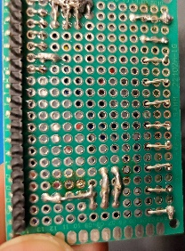
      - Prepare the push button for connection to the appropriate terminal blocks (I twist my cables and the ends of the wires together to make cable management and connection easier).
      - This is where this piece will eventually be connected.
      - The shield can now be plugged into the board. This is how it sits in the board like this:
      - Prepare some wire to connect to the terminals on the motor block (I just twisted up some wire because I had it on hand, but any color coded 4 wire solid core cable will work), making sure to make enough to give a desired length between the Arduino unit and the driver.
      - Cut a section of this cable and splay out the individual wires.
      - Strip the wires and connect them to the shield by inserting them into the terminals and turning the screws. This example has only one motor driver connected, but the shield provides connections for up to 2 motors drivers. The color correlations are important to not as they indicate what each terminal block on the shield tells the motor driver to do (also listed in figure). The connections are in the same order for adding a second motor, they’re the two open block sets. All the minuses are on the left and the pluses are on the right.
      - Acquire a bundle of these male terminated patch cables
      - Attach and secure four of them to the four motor driver terminal blocks.
      - Each motor can differ, but most have standard wire colors so if following my color scheme, connect them like this. If for some reason your conveyor turns in the wrong direction, you probably have a motor in which differs in wire color. There are wired with these plugs because it’s easier to trouble shoot if you can unplug easily. This connection is what you will change if something is wrong. Once you have it set and figured out (this testing will happen later) you can tape the individual connections together.
      - Make one of these by stripping wires, plugging them into this DC adapter terminal (comes with the recommended power supply for the motor driver). Connect the other end to the +/- of the motor driver terminal blocks.
      - Set the pins on the motor controller as such (3.31A, Half, 2000 Pulse/rev). What you will need to set this as will vary depending on motor, so please use the recommended one if possible.
      - Temporarily connect the wires between the Arduino shield and the driver by attaching them to each set of terminal blocks. Also connect the motor to the motor driver.
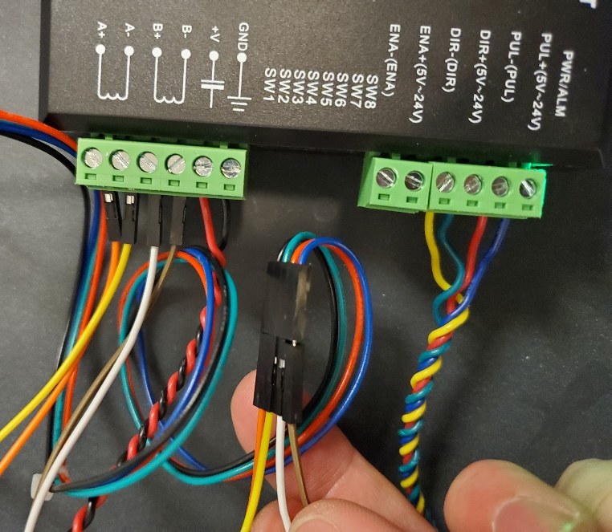
      - Attach the push button to the shield terminal blocks.
      - Disconnect the shield from the Arduino unit and attach the USB to the unit and a computer.
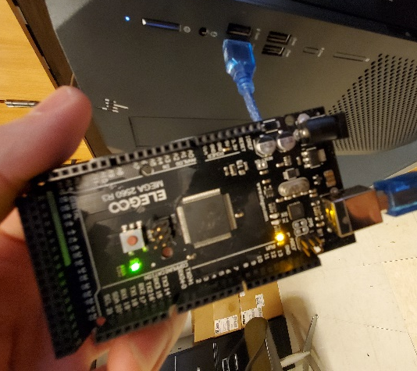
      - Use the Arduino software to upload the program (contained in our GitHub) to the unit. You may need to change the device type in the program and the port.
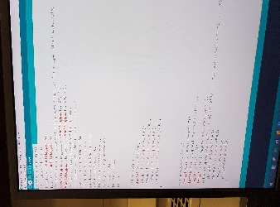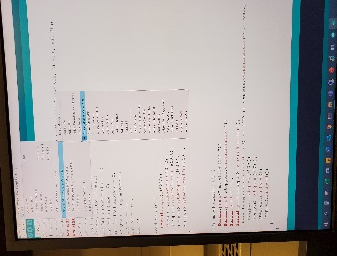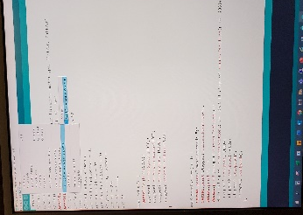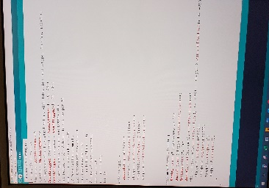
      - Unplug the Arduino unit from the USB, plug in the Arduino power supply and the shield.
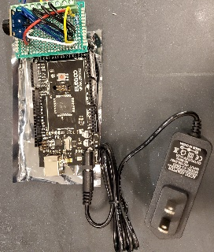
      - Plug the motor into the driver and the power supply into the driver.
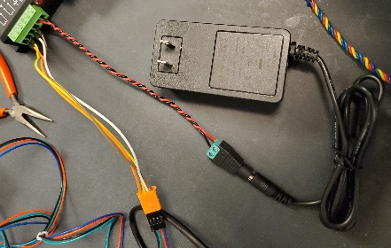
      - Plug the power supplies into power outlets.
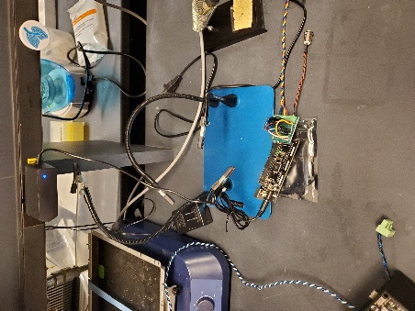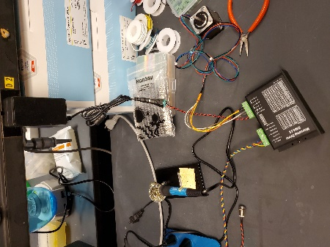
      - Moment of truth: press the button that you added to the shield. You should hear a beep and the motor should turn counterclockwise in stages.
      - Disconnect the power.
      - Troubleshoot your connections if this did not work as expected (as previously mentioned). For instance, if the motor is turning the wrong direction, your A and B are correct, but your + and – are reversed and will need to be switched. Just keep messing with the motor connection until you’ve tried all of the possibilities. If this still doesn’t work, check your terminal connections. If this still doesn’t work, check your solder work.
      - If you haven’t already, manufacture the Arduino enclosure.
      - Remove the wires connecting the shield to the motor driver terminal and remove the push button from the terminals on the shield. Remove the nut from the push button and screw the button into the buttonhole of the enclosure so the button is on the outside. Replace the nut and fasten the button into place.
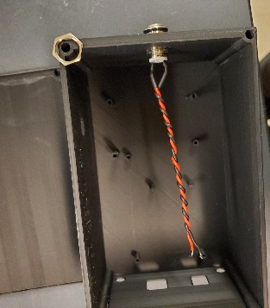
      - Insert the wires which connect the shield to the motor drivers into the holes on either side of the back of the enclosure, pull them some of the way through. Insert the Arduino unit into the enclosure, managing the wires and removing the shield in the process, and screw the Arduino unit down with 8mm M2.5 screws in the locations noted by the figure. Reattach the push button and the terminals.
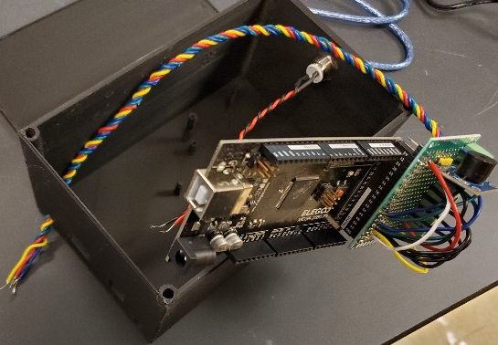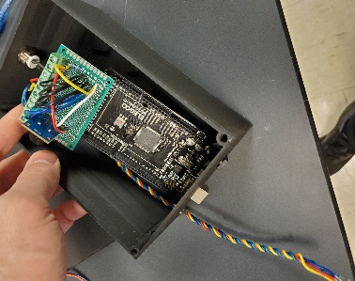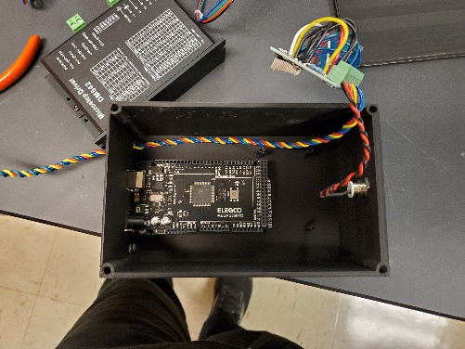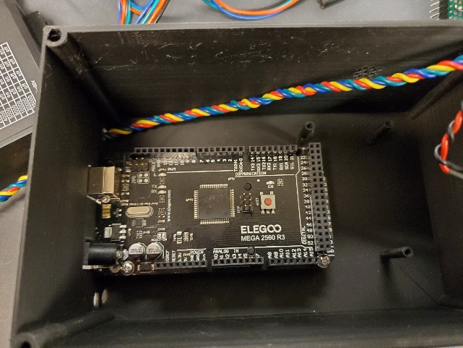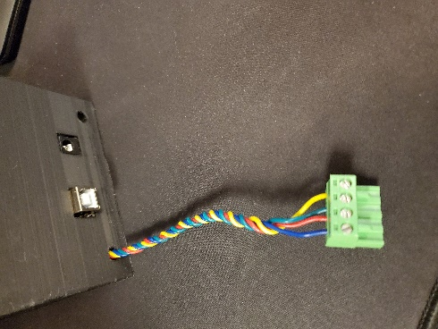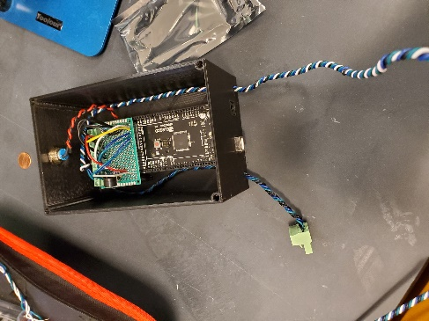
      - Reattach the shield to the Arduino unit, manage the cables, and screw the shield into place with 8mm M2 screws as indicted by the figure (if your M2 screws don’t fit, the STL file could be adjusted, but these screws aren’t necessary).
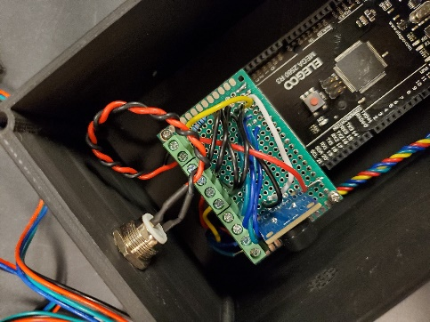
      - Check the lid to ensure that the alignment is correct, then apply the lid and screw it closed with 10mm M5 screws.
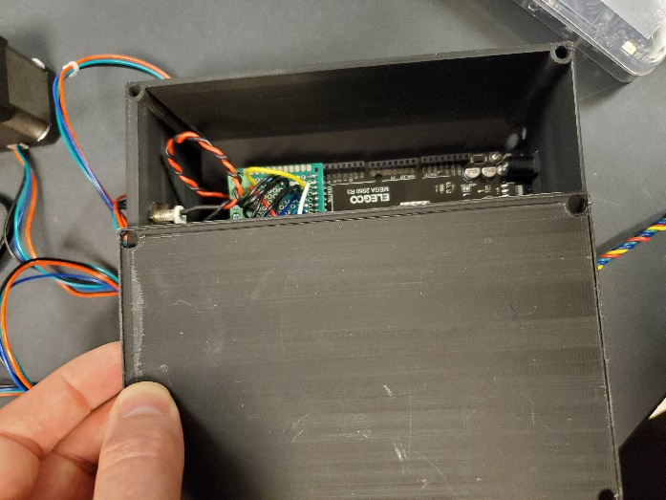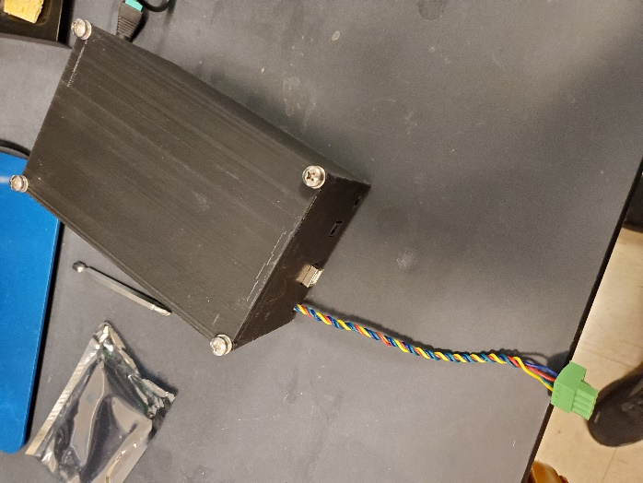
    - Connect the conveyor assembly to the Arduino and motor driver units.
      - Attach the power supply and motor supply to the motor driver.
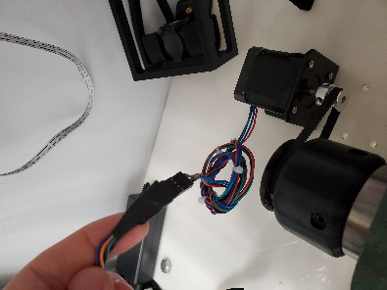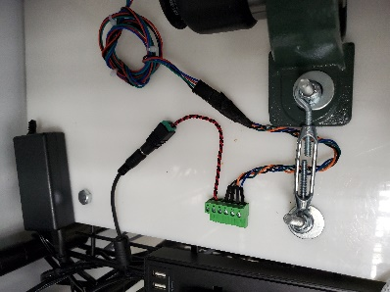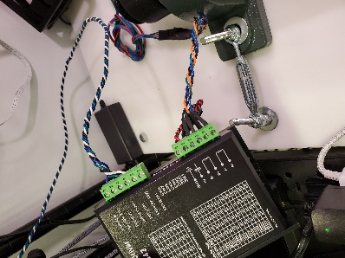
      - Plug the power supply for the Arduino unit into an interrupter switch/button and plug the interrupter and motor power supply into a surge protector with a switch set to the off position (I also installed LED puck lights (one per cage for even lighting) on a wire rack above my boxes which I plug into this and which turn on when I set turn the power supply on). TURNING THIS SWITCH OFF WHEN DONE FOR THE DAY IS ESSENTIAL OR YOU WILL BURN YOUR MOTOR OUT. Additionally, the motor gets hot. Be careful.
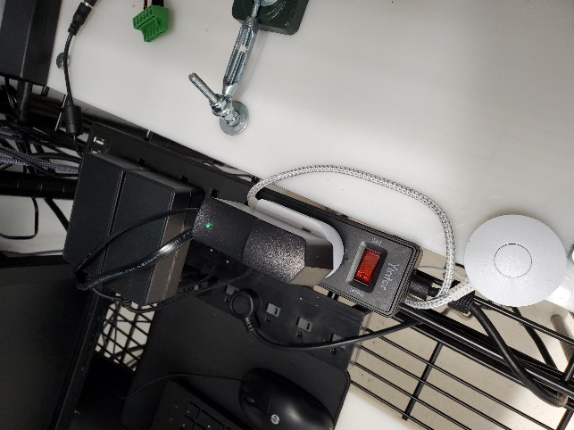
      - Connect the motor driver and Arduino unit if you have yet to do that and then plug the power supply to the Arduino unit into the Arduino unit.
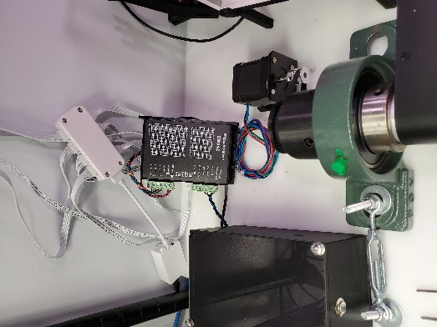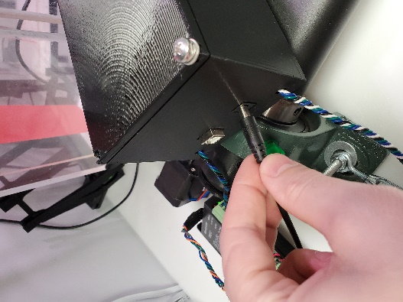
      - To turn the unit on, flip the surge protector power switch to the on position. To power on the Arduino unit, press the interrupt switch. The green light on the Arduino power supply should come on.
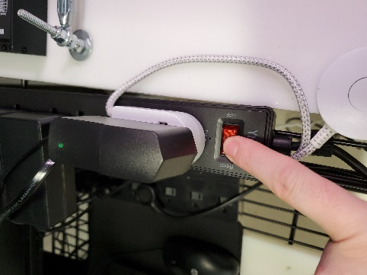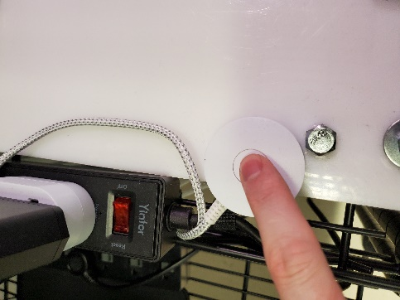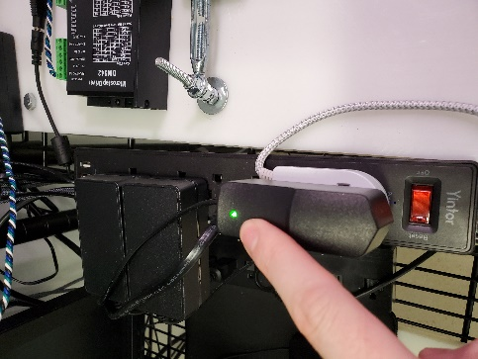
      - To run the belt, you, in theory, would press the silver Arduino enclosure button, but you should not do this yet. If you do, you can interrupt the unit by pressing the interrupt switch. This is also how you handle resetting the Arduino unit program. To completely power the unit off, flip the surge protector switch to the off position. Once again, this should be done at the end of every day of running behavior on this system.
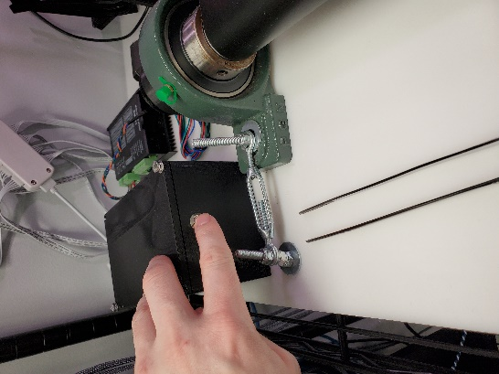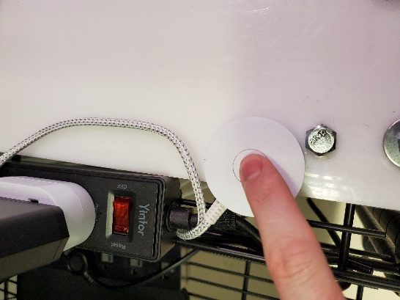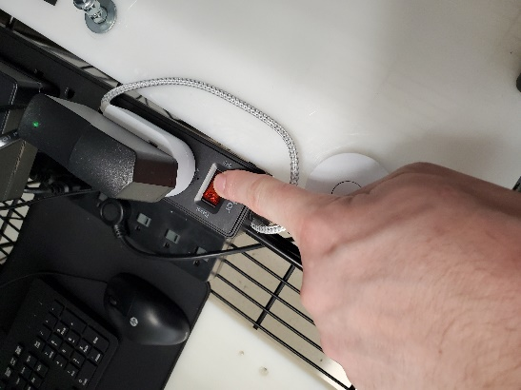
    - Tension test the unit by pressing the start button (the Arduino enclosure button) and tightening/loosening the turnbuckles and adjusting until the run pattern is stable. The Arduino program can be edited to the “tensioning” program on our GitHub to make this process easier, just remember to change it back. Once changing it back, some minor tuning of the unit might be necessary, but more coming on that soon.

